SECURITIES AND EXCHANGE COMMISSION
Washington, D.C. 20549
SCHEDULE 13D

Under the Securities Exchange Act of 1934

(Amendment No. 3)*

TRANSACT TECHNOLOGIES INC

(Name of Issuer)

Common Stock, par value $0.001 per share

(Title of Class of Securities)

(CUSIP Number)

Hitchcock Law Firm PLLC
5614 Connecticut Avenue, N.W., No. 304
Washington, DC, 20015
(202) 489-4813

(Name, Address and Telephone Number of Person Authorized to Receive Notices and Communications)
09/10/2026

(Date of Event Which Requires Filing of This Statement)

If the filing person has previously filed a statement on Schedule 13G to report the acquisition that is the subject of this Schedule 13D, and is filing this schedule because of §§ 240.13d-1(e), 240.13d-1(f) or 240.13d-1(g), check the following box.

The information required on the remainder of this cover page shall not be deemed to be “filed” for the purpose of Section 18 of the Securities Exchange Act of 1934 (“Act”) or otherwise subject to the liabilities of that section of the Act but shall be subject to all other provisions of the Act (however, see the Notes).

schemaVersion:
SCHEDULE 13D

CUSIP No.

1 | Name of reporting person  Charles M. Gillman
2 | Check the appropriate box if a member of a Group (See Instructions)  (a)  (b)
3 | SEC use only
4 | Source of funds (See Instructions)  PF
5 | Check if disclosure of legal proceedings is required pursuant to Items 2(d) or 2(e)
6 | Citizenship or place of organization  UNITED STATES
Number of Shares Beneficially Owned by Each Reporting Person With:
7 | Sole Voting Power  521,841.00
8 | Shared Voting Power  0.00
9 | Sole Dispositive Power  521,841.00
10 | Shared Dispositive Power  0.00

11 | Aggregate amount beneficially owned by each reporting person  521,841.00
12 | Check if the aggregate amount in Row (11) excludes certain shares (See Instructions)
13 | Percent of class represented by amount in Row (11)  5.1 %
14 | Type of Reporting Person (See Instructions)  IN

Comment for Type of Reporting Person:
Percent of class is calculated based on 10,276,279 shares of common stock, par value $0.01 (the "Common Stock"), of TransAct Technologies, Inc. (the "Issuer") outstanding as of April 30, 2026, as reported by the Issuer in its Quarterly Report on Form 10-Q filed with the U.S. Securities and Exchange Commission (the "SEC") on May 13, 2026 (the "10-Q").
SCHEDULE 13D

Item 1. | Security and Issuer
(a) | Title of Class of Securities:  Common Stock, par value $0.001 per share
(b) | Name of Issuer:  TRANSACT TECHNOLOGIES INC
(c) | Address of Issuer's Principal Executive Offices:  One Hamden Center, 2319 Whitney Avenue, Suite 3B, Hamden, CONNECTICUT , 06518.
Item 2. | Identity and Background
(a) | This statement is filed by Charles M. Gillman. Mr. Gillman is referred to as the Reporting Person.
(b) | The address of the principal office of the Reporting Person is 1223 Wilshire Boulevard, Unit 648, Santa Monica CA 90403.
(c) | The principal occupation of Mr. Gillman is serving as the Executive Managing Director of IDWR Office.
(d) | Mr. Gillman has not, during the last five years, been convicted in a criminal proceeding (excluding traffic violations or similar misdemeanors).
(e) | Mr. Gillman has not, during the last five years, been party to a civil proceeding of a judicial or administrative body of competent jurisdiction and as a result of such proceeding was or is subject to a judgment, decree or final order enjoining future violations of, or prohibiting or mandating activities subject to, federal or state securities laws or finding any violation with respect to such laws.
(f) | Mr. Gillman is a citizen of the United States of America.
Item 3. | Source and Amount of Funds or Other Consideration
 | The aggregate purchase price of the 521,841 Shares is approximately $2,453,646, excluding brokerage commissions.
Item 4. | Purpose of Transaction
 | The purpose of the acquisition of the Common Stock is for investment, and the acquisitions of the Common Stock were made in the ordinary course of business and were not made for the purpose of acquiring control of the Issuer. Although no Reporting Person has any specific plan or proposal to acquire or dispose of the Common Stock, consistent with its investment purpose, each Reporting Person at any time and from time to time may acquire additional Common Stock or dispose of any or all of its Common Stock depending upon an ongoing evaluation of the investment in the Common Stock, prevailing market conditions, other investment opportunities, liquidity requirements of the Reporting Persons, and/or other investment considerations. Also, consistent with the investment purpose, the Reporting Person (Mr. Gillman) may engage in communications with one or more shareholders of the Issuer, one or more officers of the Issuer and/or one or more members of the board of directors of the Issuer and/or one or more representatives of the Issuer regarding the Issuer, including but not limited to its operations. The Reporting Person may discuss ideas that, if effected, may result in any of the following: the acquisition by persons of additional Common Stock of the Issuer, an extraordinary corporate transaction involving the Issuer, and/or changes in the board of directors or management of the Issuer. Mr. Gillman believes that the company is facing unique and very complicated challenges in its BOHA business. Mr. Gillman believes that these challenges require an immediate and urgent review of the BOHA business, including an exploration of strategic alternatives. To this end, Mr. Gillman believes that it is important for the board to add multiple new directors with the skills and experience to carry out this exploration of strategic alternatives for BOHA. Mr. Gillman believes that shareholders who share these concerns should communicate their concerns directly to each member of the incumbent board of directors. Mr. Gillman believes that the by laws of the company allow shareholders holding a majority of the voting rights to call a special meeting. Mr. Gillman believes that every single shareholder should today consider whether it is advisable at this time to call a special meeting of shareholders for the purpose of electing additional members to the board. At this time, Mr. Gillman has no specific plan or proposal to acquire or dispose of his Common Stock. Mr. Gillman may from time to time acquire additional Common Stock or dispose of any or all of his Common Stock depending upon an ongoing evaluation of the investment in the Common Stock, prevailing market conditions, other investment opportunities, liquidity requirements and/or other investment considerations. Also, consistent with the investment purpose, he may engage in communications with one or more shareholders of the Issuer, one or more officers of the Issuer and/or one or more members of the board of directors of the Issuer and/or one or more representatives of the Issuer regarding the Issuer, including but not limited to its operations. Mr. Gillman may discuss ideas that, if effected, may result in any of the following: the acquisition by persons of additional Common Stock of the Issuer, an extraordinary corporate transaction involving the Issuer, and/or changes in the board of directors or management of the Issuer. Except to the extent the foregoing may be deemed a plan or proposal, he has no plans or proposals which relate to, or could result in, any of the matters referred to in paragraphs (a) through (j), inclusive, of the instructions to Item 4 of Schedule 13D. Mr. Gillman may review or reconsider his position at any time. Mr. Gillman may change his goals with respect to TransAct at any time. Except to the extent the foregoing may be deemed a plan or proposal, Mr. Gillman has no plans or proposals which relate to, or could result in, any of the matters referred to in paragraphs (a) through (j), inclusive, of the instructions to Item 4 of Schedule 13D. Mr. Gillman may, at any time and from time to time, review or reconsider their position and/or change their purpose and/or formulate plans or proposals with respect thereto. Mr. Gillman believes that Daniel Friedberg effectively owns more stock in TransAct Technologies than any other board member. For this reason Mr. Gillman believes that Mr. Friedberg should be made board chairman and calls on the board to make this change immediately.
Item 5. | Interest in Securities of the Issuer
(a) | The aggregate percentage of Shares reported owned by the Reporting Person is based upon 10,276,279 shares outstanding as of April 30, 2026, as reported by the Issuer in its Quarterly Report on Form 10-Q filed with the SEC on May 13, 2026.
(b) | 1. Sole power to vote or direct vote: 521,841 2. Shared power to vote or direct vote: 0 3. Sole power to dispose or direct the disposition: 521,841 4. Shared power to dispose or direct the disposition: 0
(c) | See Exhibit 99.1 for details.
(d) | No person other than the Reporting Persons is known to have the right to receive, or the power to direct the receipt of dividends from, or proceeds from the sale of, the Shares.
(e) | Not applicable
Item 6. | Contracts, Arrangements, Understandings or Relationships With Respect to Securities of the Issuer
 | Other than as described herein, there are no contracts, arrangements, understandings or relationships among the Reporting Person, or between the Reporting Person and any other person, with respect to the securities of the Issuer.
Item 7. | Material to be Filed as Exhibits.
 | Item 5(c) information being filed as Exhibit 99.1 A report describing Mr. Gillman's efforts is being filed as Exhibit 99.2.

SIGNATURE
After reasonable inquiry and to the best of my knowledge and belief, I certify that the information set forth in this statement is true, complete and correct.
Charles M. Gillman

Signature: | /s/ Charles M Gillman
Name/Title: | Executive Managing Director
Date: | 09/10/2026

Exhibit 99.1

Item 5(c) Transaction Description

The following table sets forth all transactions with respect to Shares effected during the past sixty (60) days by Charles M. Gillman. All such transactions were purchases of Shares effected in the open market, and the table includes commissions paid in per share prices.

None.

Exhibit 99.2

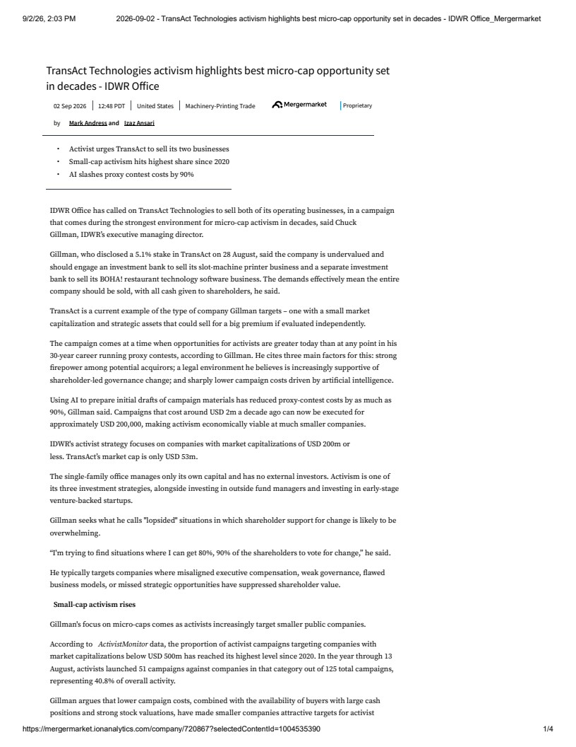
TransAct Technologies activism highlights best micro-cap opportunity setin decades - IDWR Office02 Sep 202612:48 PDTUnited StatesMachinery-Printing TradeProprietaryby Mark Andress and Izaz Ansari?Activist urges TransAct to sell its two businesses?Small-cap activism hits highest share since 2020?AI slashes proxy contest costs by 90%IDWR Office has called on TransAct Technologies to sell both of its operating businesses, in a campaignthat comes during the strongest environment for micro-cap activism in decades, said ChuckGillman, IDWR?s executive managing director.Gillman, who disclosed a 5.1% stake in TransAct on 28 August, said the company is undervalued andshould engage an investment bank to sell its slot-machine printer business and a separate investmentbank to sell its BOHA! restaurant technology software business. The demands effectively mean the entirecompany should be sold, with all cash given to shareholders, he said.TransAct is a current example of the type of company Gillman targets ? one with a small marketcapitalization and strategic assets that could sell for a big premium if evaluated independently.The campaign comes at a time when opportunities for activists are greater today than at any point in his30-year career running proxy contests, according to Gillman. He cites three main factors for this: strongfirepower among potential acquirors; a legal environment he believes is increasingly supportive ofshareholder-led governance change; and sharply lower campaign costs driven by artificial intelligence.Using AI to prepare initial drafts of campaign materials has reduced proxy-contest costs by as much as90%, Gillman said. Campaigns that cost around USD 2m a decade ago can now be executed forapproximately USD 200,000, making activism economically viable at much smaller companies.IDWR's activist strategy focuses on companies with market capitalizations of USD 200m orless. TransAct?s market cap is only USD 53m.The single-family office manages only its own capital and has no external investors. Activism is one ofits three investment strategies, alongside investing in outside fund managers and investing in early-stageventure-backed startups.Gillman seeks what he calls "lopsided" situations in which shareholder support for change is likely to beoverwhelming."I'm trying to find situations where I can get 80%, 90% of the shareholders to vote for change," he said.He typically targets companies where misaligned executive compensation, weak governance, flawedbusiness models, or missed strategic opportunities have suppressed shareholder value. Small-cap activism risesGillman's focus on micro-caps comes as activists increasingly target smaller public companies.According to ActivistMonitor data, the proportion of activist campaigns targeting companies withmarket capitalizations below USD 500m has reached its highest level since 2020. In the year through 13August, activists launched 51 campaigns against companies in that category out of 125 total campaigns,representing 40.8% of overall activity.Gillman argues that lower campaign costs, combined with the availability of buyers with large cashpositions and strong stock valuations, have made smaller companies attractive targets for activist9/2/26, 2:03 PM2026-09-02 - TransAct Technologies activism highlights best micro-cap opportunity set in decades - IDWR Office_Mergermarkethttps://mergermarket.ionanalytics.com/company/720867?selectedContentId=10045353901/4

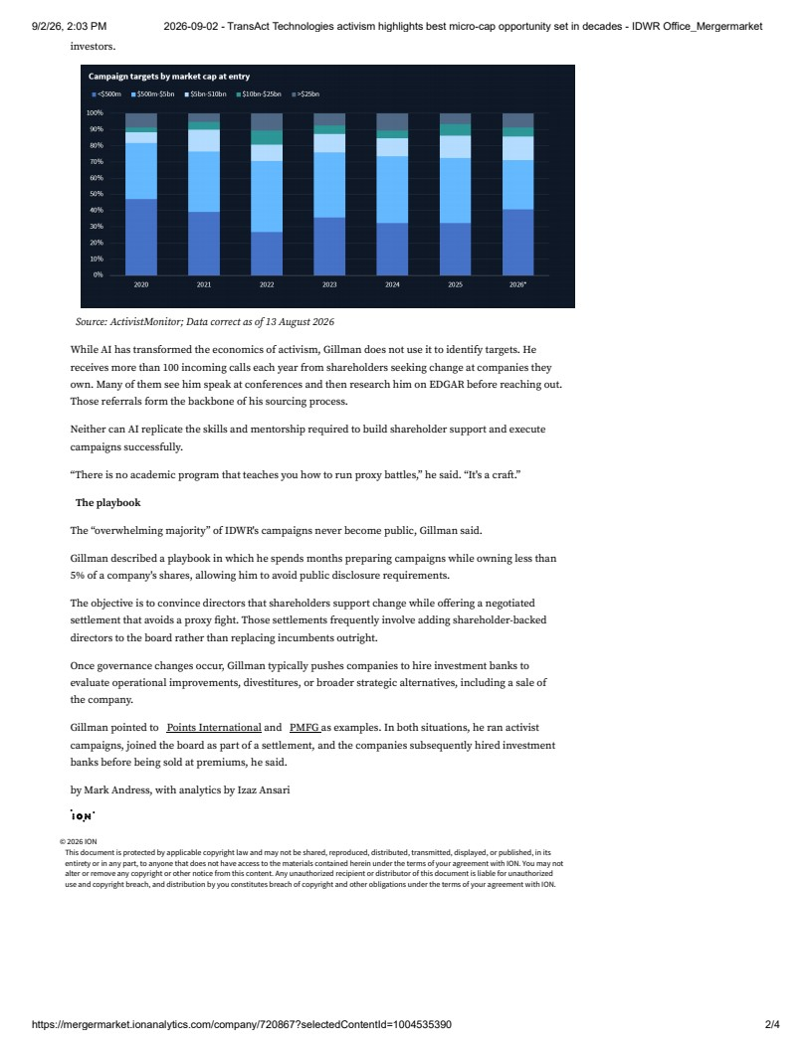
investors.Source: ActivistMonitor; Data correct as of 13 August 2026While AI has transformed the economics of activism, Gillman does not use it to identify targets. Hereceives more than 100 incoming calls each year from shareholders seeking change at companies theyown. Many of them see him speak at conferences and then research him on EDGAR before reaching out.Those referrals form the backbone of his sourcing process. Neither can AI replicate the skills and mentorship required to build shareholder support and executecampaigns successfully. "There is no academic program that teaches you how to run proxy battles," he said. "It's a craft."The playbookThe "overwhelming majority" of IDWR's campaigns never become public, Gillman said.Gillman described a playbook in which he spends months preparing campaigns while owning less than5% of a company's shares, allowing him to avoid public disclosure requirements.The objective is to convince directors that shareholders support change while offering a negotiatedsettlement that avoids a proxy fight. Those settlements frequently involve adding shareholder-backeddirectors to the board rather than replacing incumbents outright.Once governance changes occur, Gillman typically pushes companies to hire investment banks toevaluate operational improvements, divestitures, or broader strategic alternatives, including a sale ofthe company.Gillman pointed to Points International and PMFG as examples. In both situations, he ran activistcampaigns, joined the board as part of a settlement, and the companies subsequently hired investmentbanks before being sold at premiums, he said.by Mark Andress, with analytics by Izaz Ansari© 2026 IONThis document is protected by applicable copyright law and may not be shared, reproduced, distributed, transmitted, displayed, or published, in itsentirety or in any part, to anyone that does not have access to the materials contained herein under the terms of your agreement with ION. You may notalter or remove any copyright or other notice from this content. Any unauthorized recipient or distributor of this document is liable for unauthorizeduse and copyright breach, and distribution by you constitutes breach of copyright and other obligations under the terms of your agreement with ION.9/2/26, 2:03 PM2026-09-02 - TransAct Technologies activism highlights best micro-cap opportunity set in decades - IDWR Office_Mergermarkethttps://mergermarket.ionanalytics.com/company/720867?selectedContentId=10045353902/4

